RCInstaller guidelinesRCInstaller guidelines

Revision History
Ver. | Date | By | List of changes
1.0 | 23/04/2007 | Max Sogin | Initial

References
RCInstaller.eap

Content
Revision History 1
References 1
Content 2
Init Page workflow 2
Currently implemented workflow 2
Major upgrade issues: 3
Install / Update feature workflow 3
RCInstaller update open issues: 3
RCInstaller COM interface 4
RCInstaller modules list 4

Init Page workflow

Currently implemented workflow
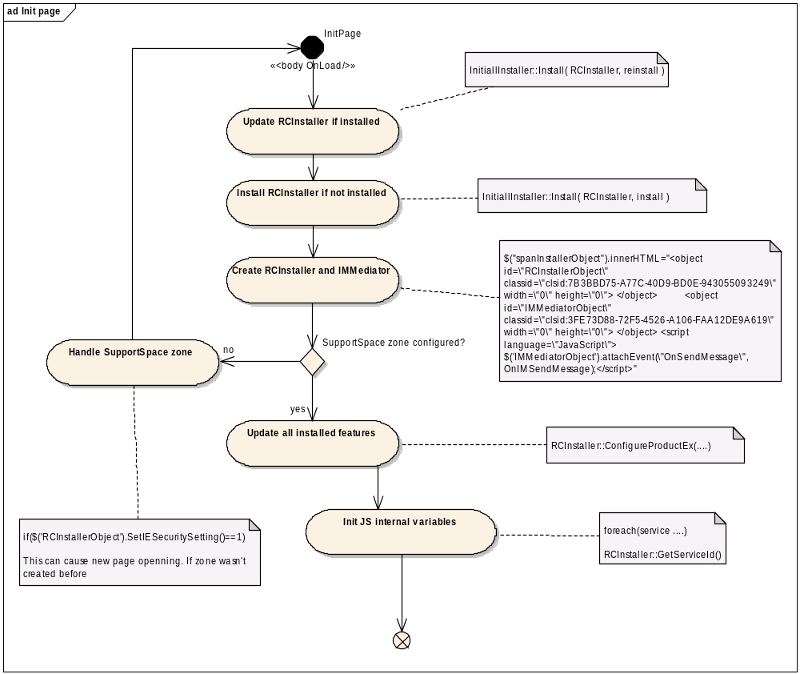

Major upgrade issues:
Currently implemented workflow will work till major changes in msi occurred. To handle major changes in msi, Microsoft proposes to use major upgrade technique, see http://msdn2.microsoft.com/en-us/library/aa369786.aspx for details.
In case of making major upgrade, following issues will happened with currently implemented workflow:
- RCInstaller will be forcibly reinstalled
- All other installed features will be removed
To solve these issues following methods could be used:
- Store installed features history with means of RCInstaller or JS, and reinstall them during major update
- Handle such upgrades, using migrate feature states in MSI script. See http://msdn2.microsoft.com/en-us/library/aa370034.aspx for details

Install / Update feature workflow
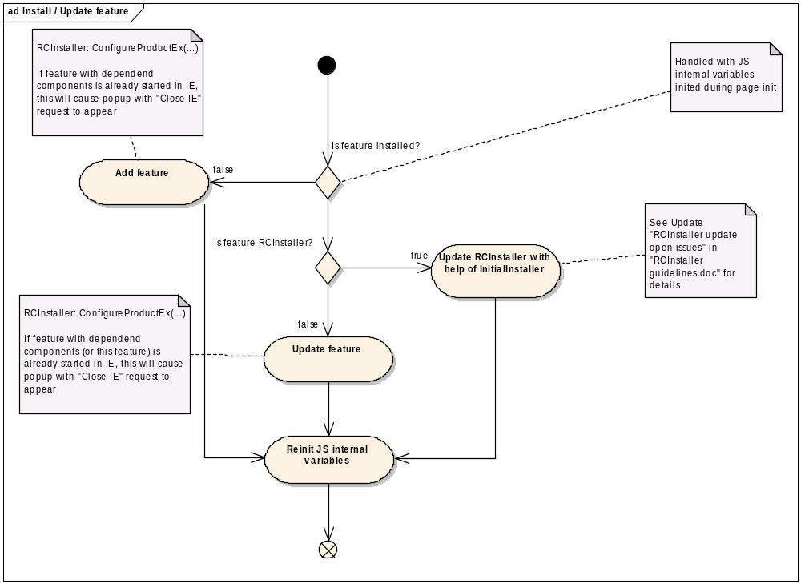

RCInstaller update open issues:
Since RCInstaller.dll cannot be unloaded from IE. We will get “Cloes IE” popup, in case of msi interface turned on, or we’ll get system reboot in case of msi interface turned off.
This can happened in following cases:
- RCInstaller update was requested after page was loaded.
- RCInstaller update was requested on page load, but another IE instance already running with not updated instance of RCInstaller
Possible ways of handling this:
TODO: define if such exists

RCInstaller COM interface
TODO: fill following table
type | method | description
method | Start( featureId)

RCInstaller modules list
module name | binaries list | description
NWL | aidlib.dll  nwl.dll  w32gnutls.dll | Network layer
RCInst | RCInstaller.dll | RCInstaller service
RCUI | RCUI.dll  vnchooks.dll | Remote control service
FTUI | FTUI.dll | File access service
SuppMes | SupportMessenger.exe  Communicator.dll | SupportSpace messenger
NetLogLb | NetLogLib.dll | NetLog library outproc com. If installed, then multiple netlog clients become available from one host
NLWiever | NetLogViewer.exe  Interop.NetLogViewerLib.dll  NetLogViewerLib.dll | NetLog viewer
CRT | Microsoft.VC80.DebugCRT.manifest  msvcp80d.dll  msvcr80d.dll | Dynamic crt lib. In dynamic version used by all modules, except for RCInstaller
MFC | mfc80d.dll  Microsoft.VC80.DebugMFC.manifest | MFC. Used by SuppMess module

